8.2

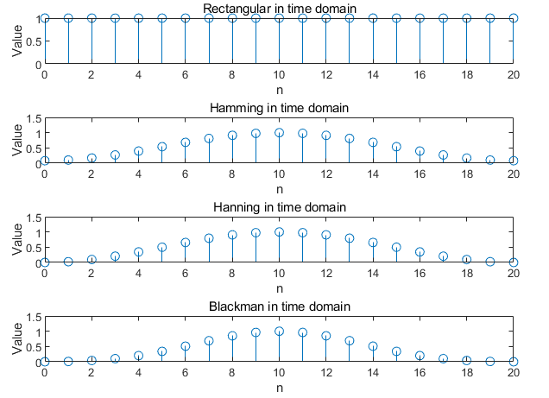

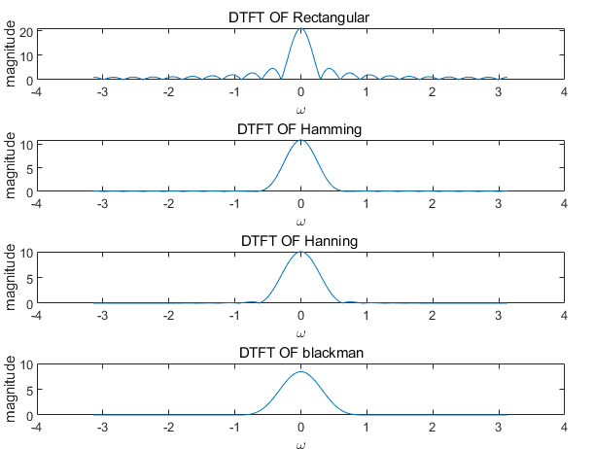

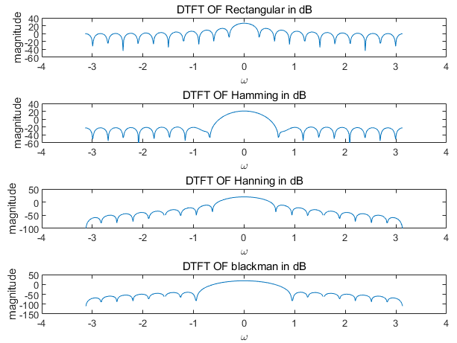

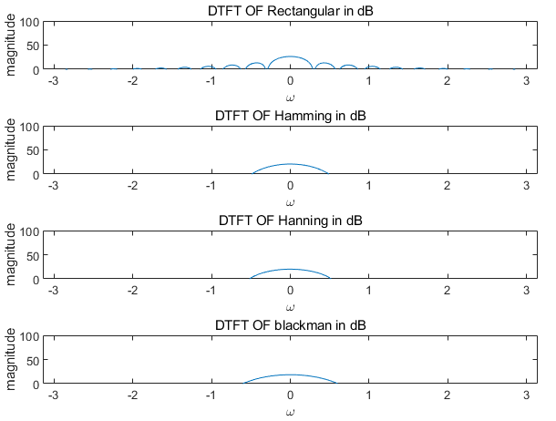

Experimental result

|  |  |  |
| --- | --- | --- |
| Window(N=21) | Mainlobe width | Peak-to-sidelobe amplitude(dB) |
| Rectangular | 0.58769 | -12.973 |
| Hanning | 1.19587 | -31.856 |
| Hamming | 1.19623 | -42.987 |
| Blackman | 1.79469 | -57.986 |

Theoretical result

|  |  |  |
| --- | --- | --- |
| Window(N=21) | Mainlobe width | Peak-to-sidelobe amplitude(dB) |
| Rectangular | 4pi/21≈0.59840 | -13 |
| Hanning | 8pi/21≈1.19680 | -32 |
| Hamming | 8pi/21≈1.19680 | -43 |
| Blackman | 12pi/21≈1.79520 | -58 |

The experimental result is very close to theoretical result. Generally, with the width of mainlobe increasing, the peak-to-sidelobe amplitude become larger.

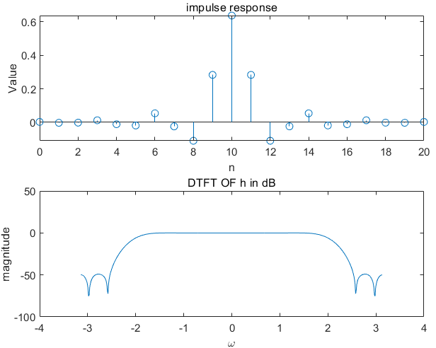

8.3

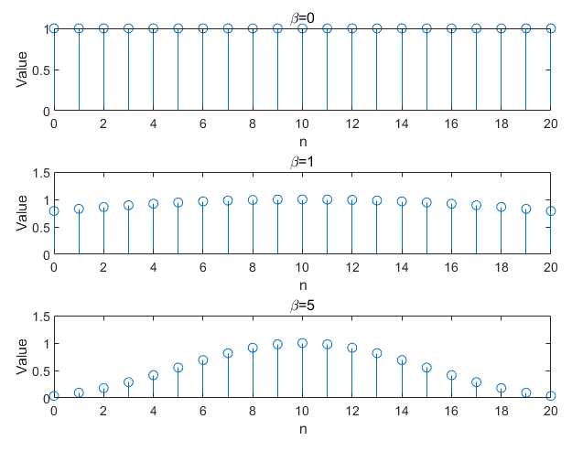

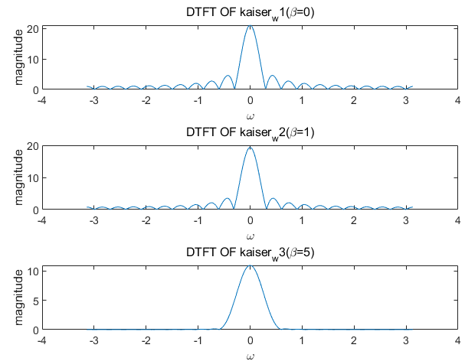

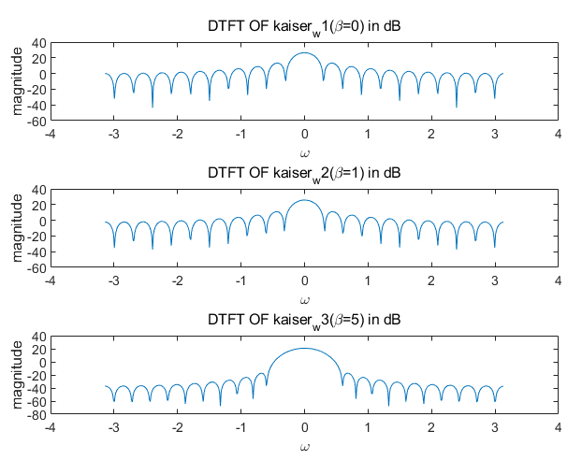 ,,,,

With $β$ increasing, the shape of the window is more like lobe. With $β$ increasing, the amplitude of sidelobes of the DTFT reduce gradually.

$$β=4.0909$$

$$N=43$$

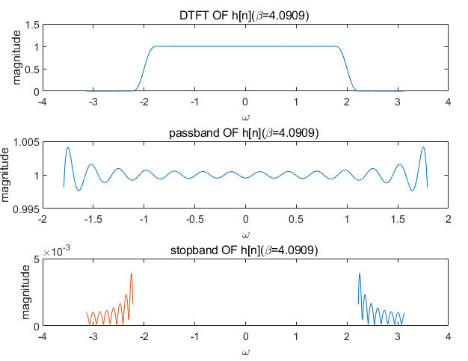

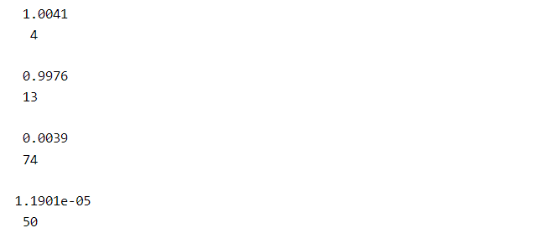

Passband ripple: max{0.0041,0.0034}=0.0041

Stopband ripple: 0.0039

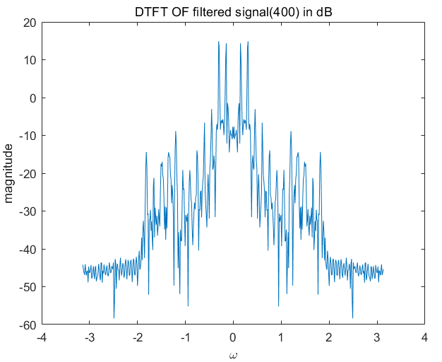

The high frequency signal is noise and has been removed basically. After filter, the voice is much more clear.

8.4

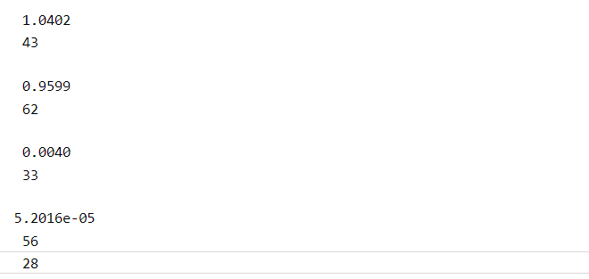

The filter length is 28+1=29. Passband ripple:0.0402 stopband ripple:0.0040

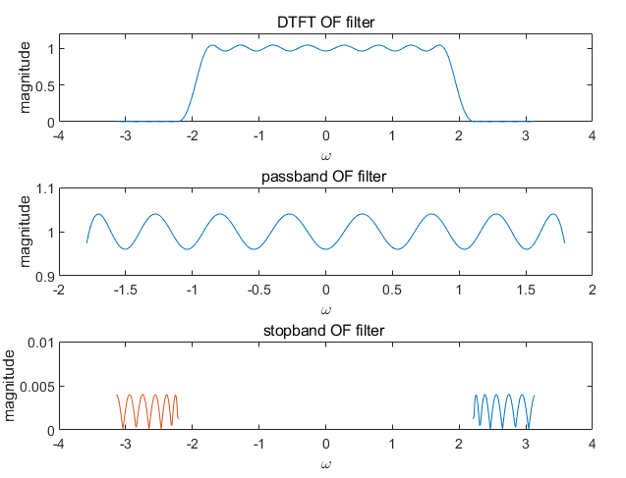

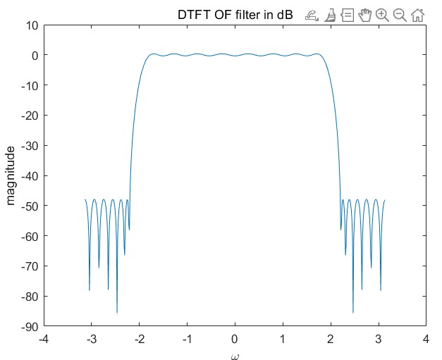

Compared to the filter designed using the Kaiser window, the fluctuation of passband and stopband is Steady and orderly. Passband ripple equals to stopband ripple.

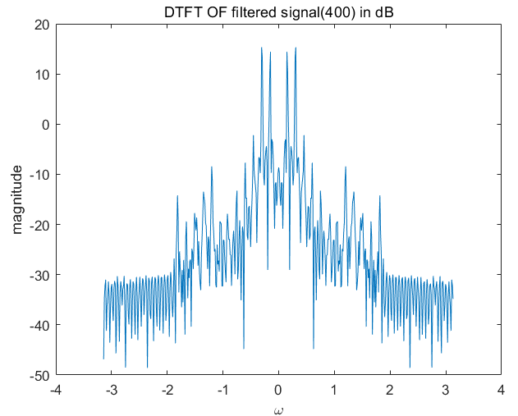

The high frequency signal is noise and has been removed basically. Compared to the filter speech using Kaiser filter, the filter speech using Parks-McClellan filter is mixed with a slightly pronounced noise.